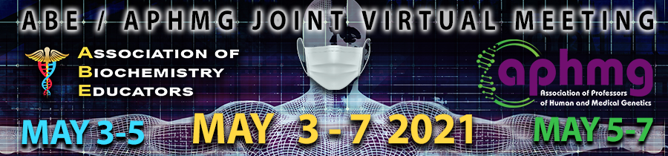

CALL FOR PROPOSALS - SUBMISSION INSTRUCTIONS

I. VIRTUAL PRESENTATION FORMAT TYPE
Workshop
Workshops are interactive learning sessions designed to facilitate skill-building. Most workshops should be designed for delivery to all participants (100-130 participants), but some may be designed for smaller breakout audiences (25-30 participants). Duration: 60 minutes
Education Discussion Group Session (EDGrS)
EGDrS are led by 1-2 facilitators who guide participants through discussion of an educational issue or theme. Duration: 60 minutes, including a brief introduction (<5 minutes and up to three slides) by the facilitators followed by a discussion amongst the attendees. NOTE: These sessions should NOT be used as time to deliver ‘short talks’.
Panel Discussion
Panel Discussions explore a range of perspectives and approaches to a well-defined educational issue. Duration: 60 minutes. Begins with a <5 minute presentation by a moderator and < 2 minute presentation by each co-panelist and is followed by a discussion with panel and audience. Limit of five panelists, including the moderator. The panel discussion should address specific questions or issues clearly stated by the moderator. NOTE: Panel moderator MUST ensure that adequate time is preserved for meaningful discussion with the audience and will manage the discussion to prevent a monopoly by individual audience or panel members.

II. PROPOSAL CONTACT & CO-AUTHOR INFORMATION
Proposals must be reviewed and approved by ALL PRESENTERS prior to submission. All presenters MUST be listed on the proposal. Accepted submissions will be asked to submit an abstract (including all co-authors) at a later date.
- Primary Presenter (primary contact person): Full Name/Degree, Institution, Email, Telephone, Cell Phone, Mailing Address

- Additional Presenters: Full Name/Degree, Institution, Email, Cell Phone

III. PRESENTATION PROPOSALS
Title
Author(s)
Background
Educational Objectives: – Please list 2-3 objectives using action words similar to those in Bloom’s taxonomy
Format/Methods: Please provide a brief timeline of how you expect your presentation to proceed and the methods used – i.e. What the audience will be doing.
Products/Materials: Please describe any products that members will generate by participation in your session (writing questions, generating an organizational tool, etc.) or any materials that will be utilized either before or during the session (survey before meeting, everyone gets a metabolic map, etc.) please enter N/A if this does not apply to your proposed session.
Learner Assessment/Outcomes: Please describe how the members will know if they have met the objectives of the session or how the session will help them be a better educator/ faculty/colleague. (can use product generated above to accomplish an educational or professional goal, etc.)

IV. REVIEW CRITERIA FOR PROPOSALS
- Importance/Significance of the Topic: Does the topic of the session address a significant issue? Is it relevant for a national audience?
- Appropriateness of Topic: Does the session address an issue that will be of interest to attendees at the meeting?
- Approach: Does the session provide practical information that adequately addresses the stated issue?
- Clarity: Is the session well thought out and clearly presented in the abstract?
- Plan to Promote Discussion/Interaction: Does the session present a clear and adequate plan to promote discussion and interaction among attendees?
- Generalizability / Transferability: Will the session provide attendees with high quality information that they can take back to their home institutions? Can information learned at the session be transferred to other settings or institutions?
- Qualifications of Presenters. Do the presenters appear to be well-qualified to lead the session?

V. SUGGESTED TOPICS FOR 2021 CONFERENCE WORKSHOPS, EDGrS, AND PANEL DISCUSSIONS
A. Active Learning – engaging dental, medical, and pharmacy students. Examples: Novel approaches to interactive learning; Life-long learning (master adapter learner); Self-directed learning
B. Integration of Biochemistry Teaching and Learning. Examples: Integration of biochemistry, genetics, and molecular biology; Biochemistry in Inter-Professional Education (IPE); Assessment and teaching strategies focused on integration
C. Education Research Methodologies. Examples: Designing Quantitative, Qualitative or Mixed Methods Research Studies
D. Scientific Updates on Emerging Medical Areas
E. Professional Development, Student Assessment and/or Remediation. Examples: Instruction on new teaching and research skills; Career development for promotion and tenure through educational scholarship
F. Distance/Remote Instruction. Examples: Best practices; How do teaching/learning goals change?; How do we support student learning in a virtual environment?; How does assessment change in a virtual learning environment?; Student engagement in a virtual learning environment?; Student wellness
G. Program Evaluation. Examples: What are the outcomes of your instructional program (course, block, etc…)?; Program design with outcomes in mind; What are the values of the various stake holders for your program?

